### Step 1: Download JDK

1. **Go to the Oracle JDK download page**: [Oracle JDK Download](https://www.oracle.com/java/technologies/javase-jdk-downloads.html" \t "_new).
2. **Select the Windows option** under "Operating System" and download the appropriate version (usually x64 Installer).

### Step 2: Install JDK

1. **Run the installer** after the download is complete.
2. **Click Next** on the setup screen.
3. **Select installation location** or use the default location (e.g., C:\Program Files\Java\jdk-<version>).
4. Click **Next**, and the installation will proceed.
5. When done, click **Close**.

### Step 3: Set up Environment Variables

1. **Open the Start menu** and search for **Environment Variables**. Select **Edit the system environment variables**.
2. In the **System Properties** window, click the **Environment Variables** button.
3. Under **System Variables**, scroll down and select **Path**, then click **Edit**.
4. In the **Edit Environment Variable** window, click **New** and add the path to your JDK's bin folder. Example: C:\Program Files\Java\jdk-<version>\bin.
5. Click **OK** to close all windows.

### Step 4: Verify Installation

1. Open **Command Prompt** (cmd).
2. Type java -version to verify that Java is correctly installed.

JMeter version:5.6.3

### Step 1: Install JMeter

1. **Download Apache JMeter**: Visit the apache-jmeter-5.6.3 (2).zip and download the latest version.
2. **Extract the JMeter ZIP file**: Extract it to a preferred location on your machine.
3. **Run JMeter**: Navigate to the bin directory and run jmeter.bat (for Windows) or jmeter.sh (for macOS/Linux).

Eg. Navigate to C:\Users\nm22220\Downloads\apache-jmeter-5.6.3\apache-jmeter-5.6.3\bin, then go to System Environment Variables, select 'Path', and copy the bin path. After that, click 'OK' (For windows).

### Step 2: Create a Test Plan

1. **Open JMeter**: Once launched, you’ll see an empty test plan.

* **Go to your downloads folder** where you've stored Apache JMeter.
* Navigate to apache-jmeter-5.6.3\apache-jmeter-5.6.3.
* Open the bin **folder**.
* Find and double-click the ApacheJMeter.jar file to launch JMeter.

### 2. ****Create a New Test Plan****

* In the menu, go to **File > New** to create a new Test Plan.

### 3. ****Add Thread Group****

* Right-click on **Test Plan** in the left pane.
* Select **Add > Threads (Users) > Thread Group**.
* In the **Thread Group** settings, you can configure the number of users (threads), ramp-up period, and loop count.

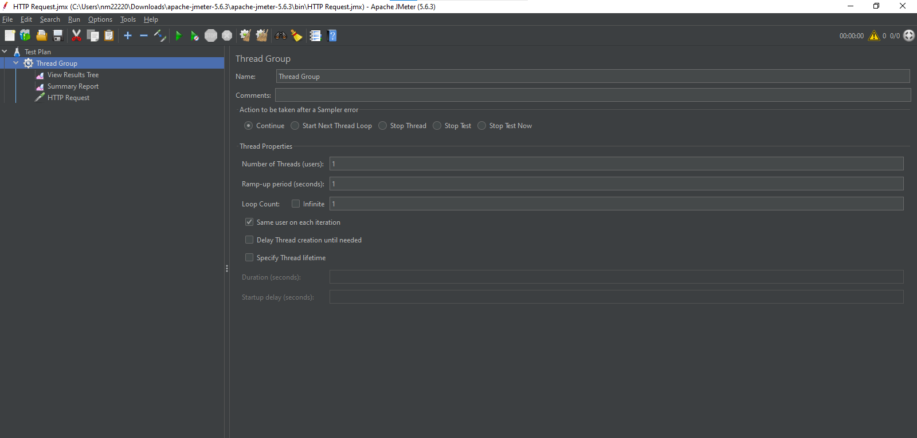

### 4. ****Add HTTP Request Sampler****

* Right-click on the **Thread Group** you just added.
* Select **Add > Sampler > HTTP Request**.
* In the **HTTP Request** window:
  + **Protocol**: Enter http or https based on your endpoint.
  + **Server Name or IP**: Enter the domain (e.g., www.example.com).
  + **Port**: If necessary, specify the port (optional if using default ports 80 or 443).
  + **Method**: Select **GET** from the dropdown.
  + **Path**: Specify the resource path (e.g., /api/resource).

### 5. ****Add HTTP Request Defaults (Optional)****

* If you have multiple HTTP requests to the same server, you can configure default settings.
* Right-click on **Thread Group** and select **Add > Config Element > HTTP Request Defaults**.
* Enter your **server name**, **protocol**, and other defaults, so you don't have to repeat them for every request.

### 6. ****Add View Results Tree Listener****

* Right-click on **Thread Group**.
* Select **Add > Listener > View Results Tree**.
* This listener will show the response for each GET request.

### 7. ****Run the Test****

* Click the **green start button** (or press Ctrl + R) to run your test.
* After the test completes, go to the **View Results Tree** to see the request, response code, and data returned by the server.

### Steps to Send a Bearer Token in JMeter:

1. **Open JMeter** and create a **Test Plan**.
2. **Add a Thread Group**:

* Right-click on the **Test Plan**.
* Choose **Add > Threads (Users) > Thread Group**.

3.**Add an HTTP Request Sampler**:

* Right-click on the **Thread Group**.
* Select **Add > Sampler > HTTP Request**.
* Enter the details of your request (Server Name, Path, Method, etc.).

4.**Add an HTTP Header Manager**:

* Right-click on the **HTTP Request**.
* Choose **Add > Config Element > HTTP Header Manager**.

5.**Add the Bearer Token in the Header**:

* In the **HTTP Header Manager**, add a new row.
* In the **Name** field, type Authorization.
* In the **Value** field, type Bearer <your\_token>. Replace <your\_token> with your actual Bearer token.

6.**Set Additional Header**:

* If needed, add other headers like Content-Type (e.g., application/json).

7. **Add a Listener** to view the results:

* Right-click on the **Thread Group**.
* Select **Add > Listener > View Results Tree** or **View Results in Table**.

8.**Run the Test**:

* Click the **Run** button (green arrow) on the toolbar to execute the request.

Example:

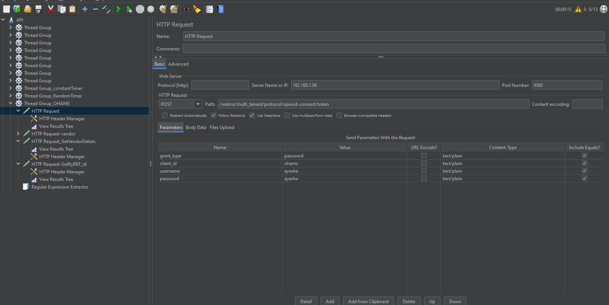

### ****Add HTTP Header Manager****

* POST requests often need specific headers (like Content-Type).
* Right-click on **Thread Group** and select **Add > Config Element > HTTP Header Manager**.
* Add the necessary headers. For example:
  + **Name**: Content-Type, **Value**: application/json (for JSON requests)
  + **Name**: Content-Type, **Value**: application/x-www-form-urlencoded (for form data)

**Example:**

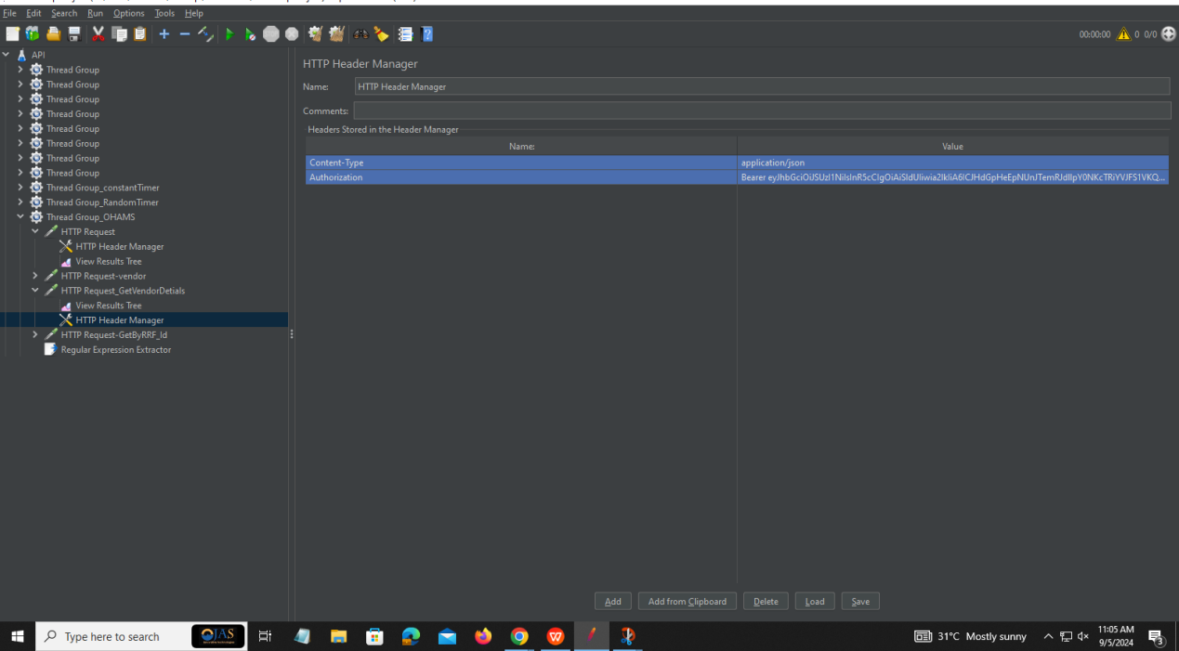

### Example Configuration for GET Request:

* **Server Name or IP**: jsonplaceholder.typicode.com
* **Method**: GET
* **Path**: /posts/1

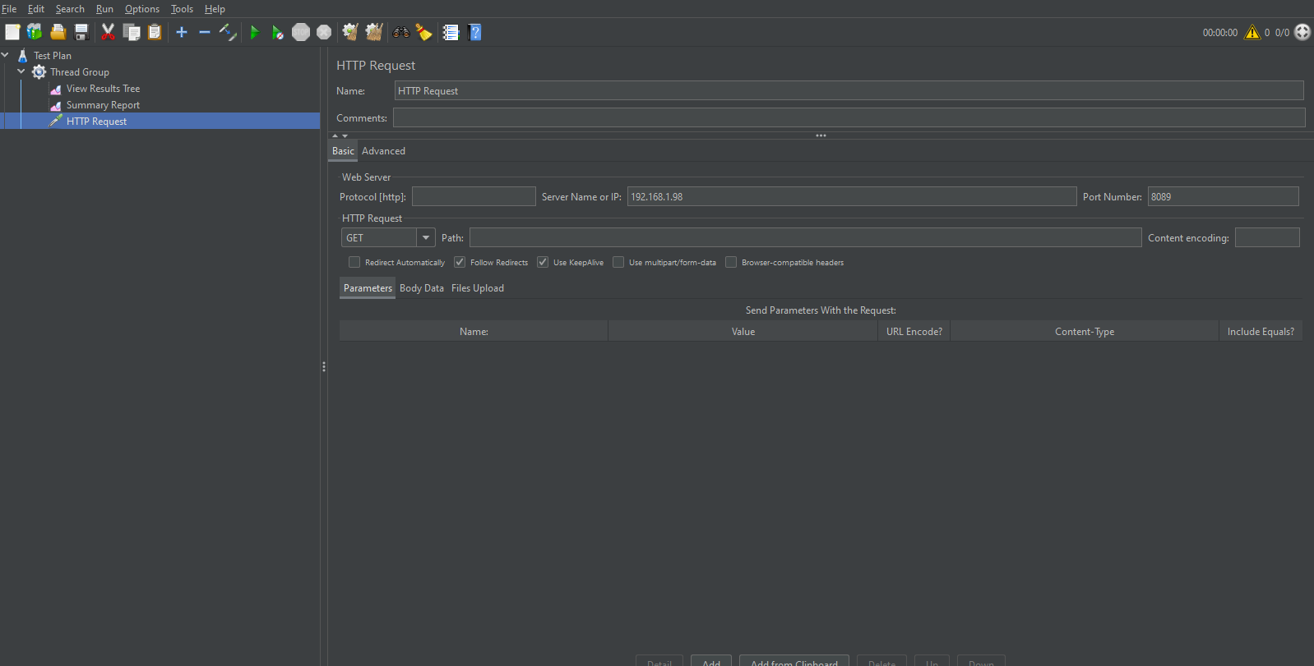

**Post Request:**

· **Server Name or IP**: jsonplaceholder.typicode.com

· **Method**: POST

· **Path**: /posts

· **Body Data**:

· json

{

"title": "foo"

}

Example:

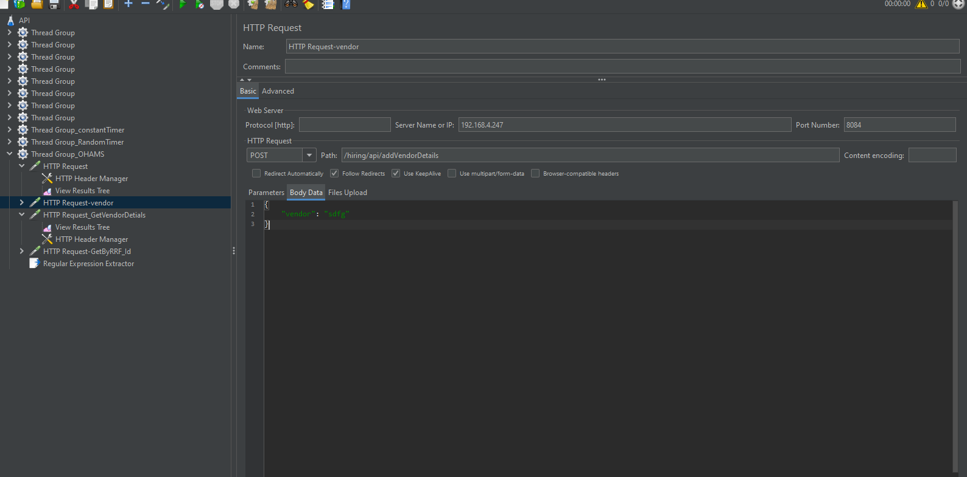

### ****Add Listeners to View Results****

Listeners in JMeter are used to visualize the performance results. Here’s how you can add listeners:

* **Step 1:** Open your test plan in JMeter.
* **Step 2:** Right-click on the **Thread Group** or any test element in the test plan.
* **Step 3:** Select **Add** > **Listener**.
* **Step 4:** Choose from the available listeners to view results, such as:

**View Results Tree** /Response

